**LAB # 03**

**K-NEAREST NEIGHBOR (KNN) ALGORITHM**

**OBJECTIVE**

Implementing K-Nearest Neighbor (KNN) algorithm to classify the data set.

**Lab Tasks:**

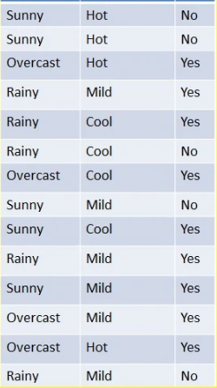

1. Implement K-Nearest Neighbor (KNN) Algorithm on the above dataset in Fig 1 to predict whether the players can play or not when the weather is overcast and the temperature is mild.Also apply confusion Matrix.

**SOURCE CODE:**

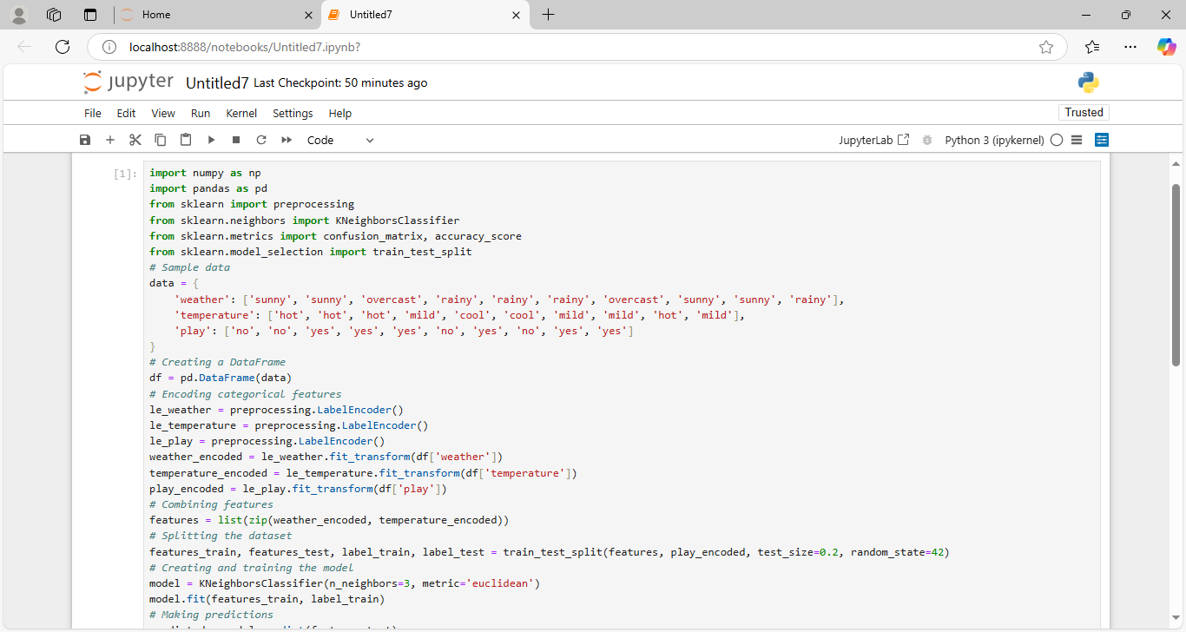

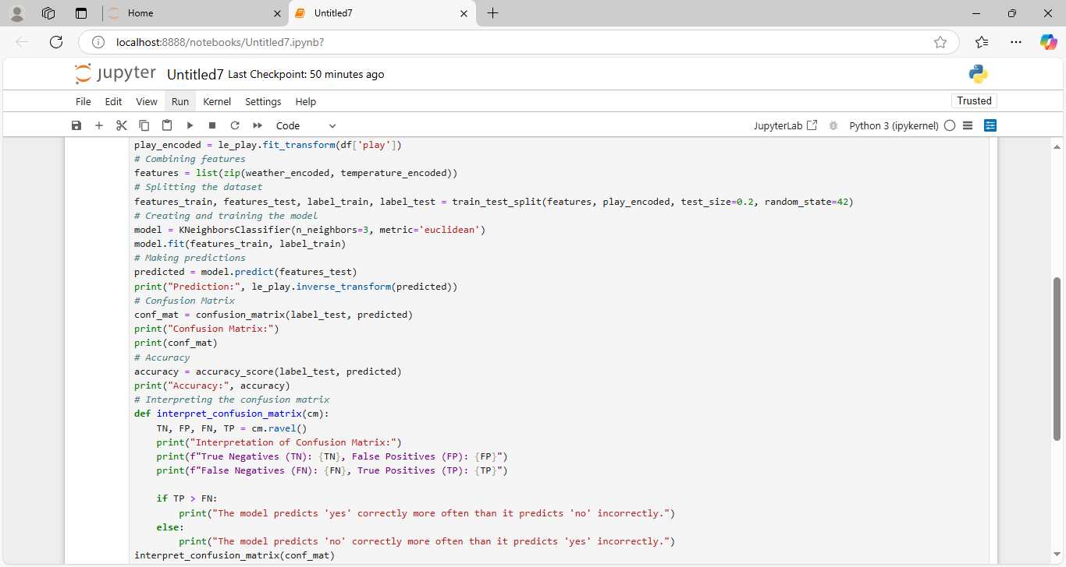

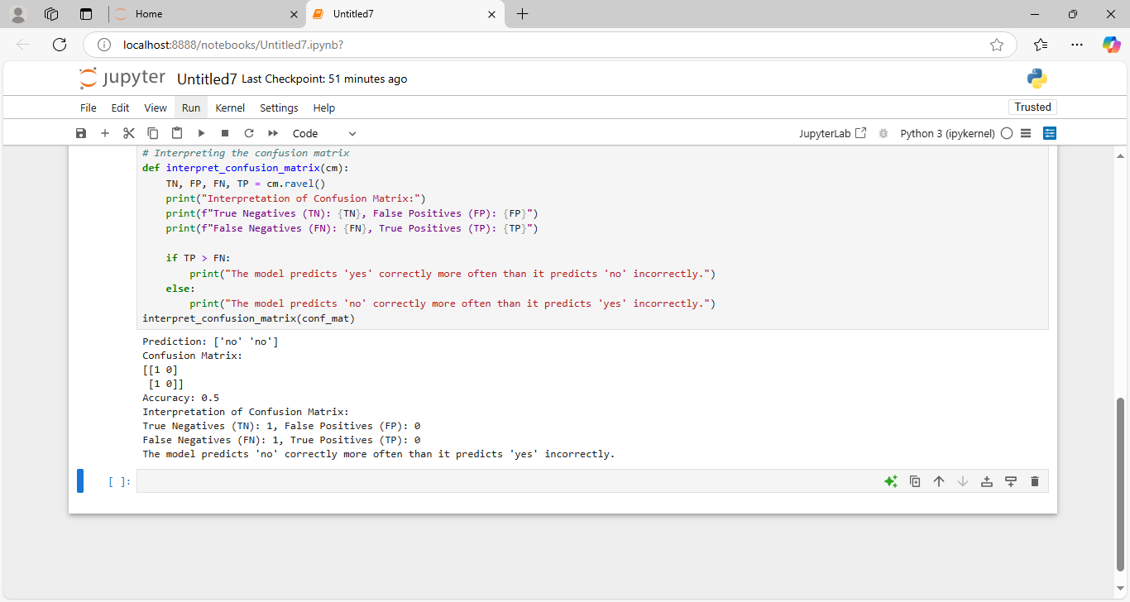

**OUTPUT:**



1. Here are 4 training samples. The two attributes are acid durability and strength. Now the factory produces a new tissue paper that passes laboratory test with X1=3 and X2=7. Predict the classification of this new tissue.

**X1= Acid durability (sec)**  **X2=Strength (kg/m2)** **Y=Classification**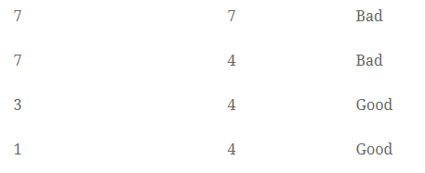

**SOURCE CODE:**

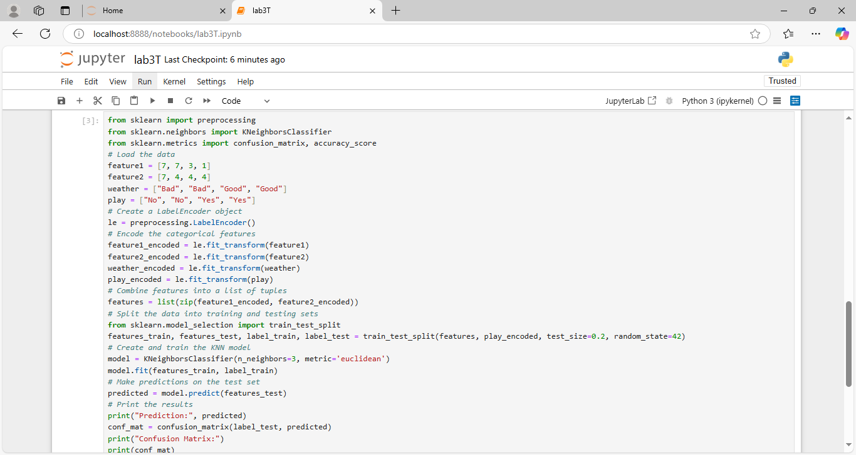

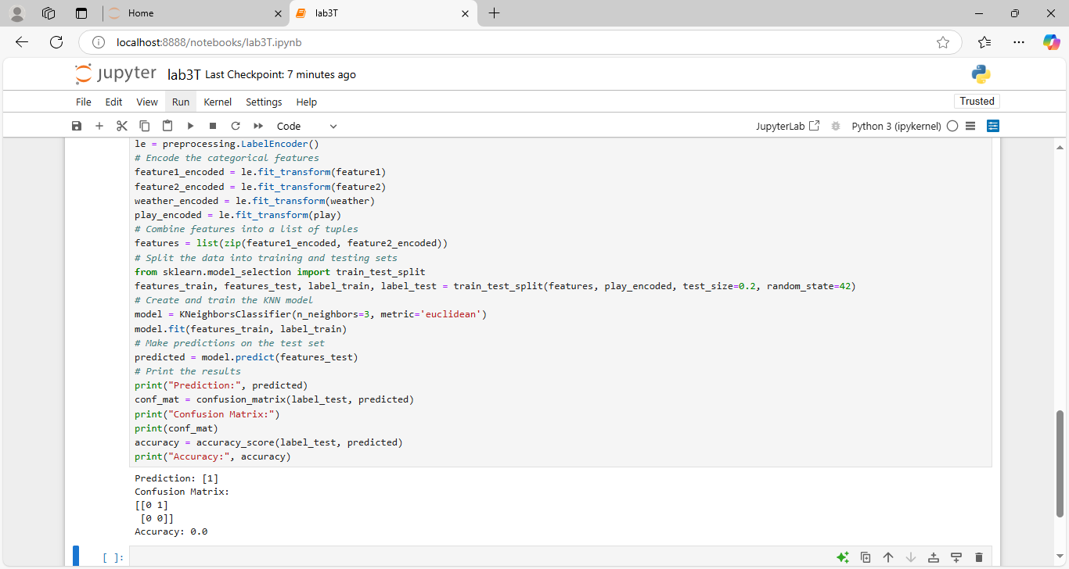

**OUTPUT:**



* Calculate the Euclidean Distance between the query instance and all the training samples. Coordinate of query instance is (3,7).

Suppose K = number of nearest neighbors = 3, sort the distances and determine nearest neighbors. Gather the class (Y) of the nearest neighbors. Use majority of the category of nearest neighbors as the prediction value of the query instance.

**SOURCE CODE:**

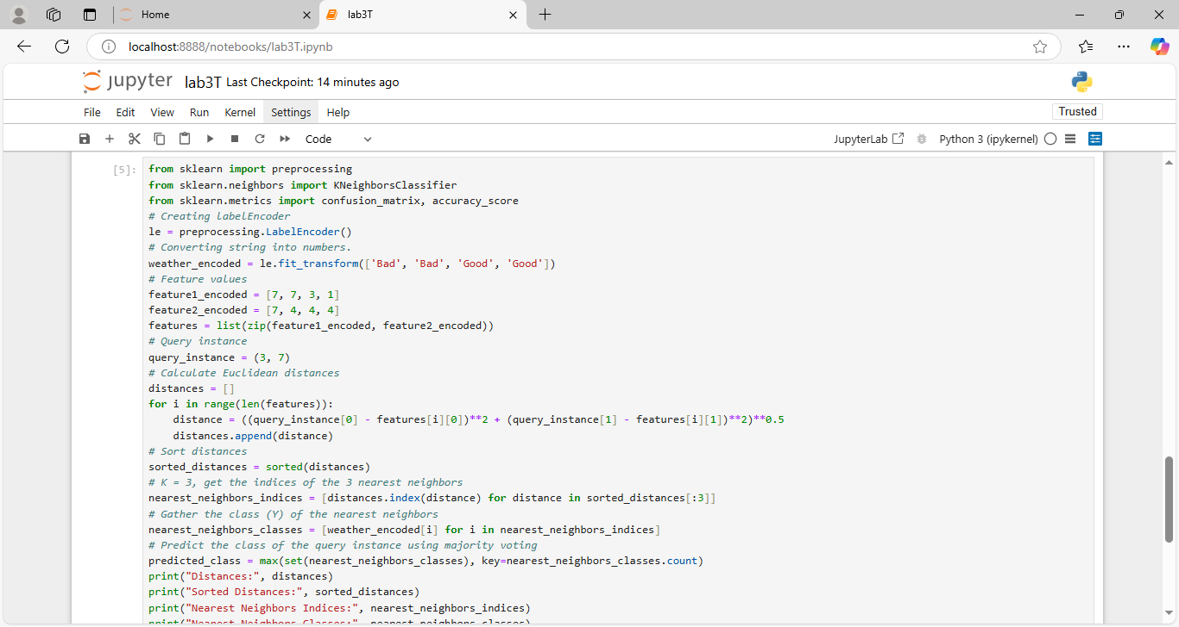

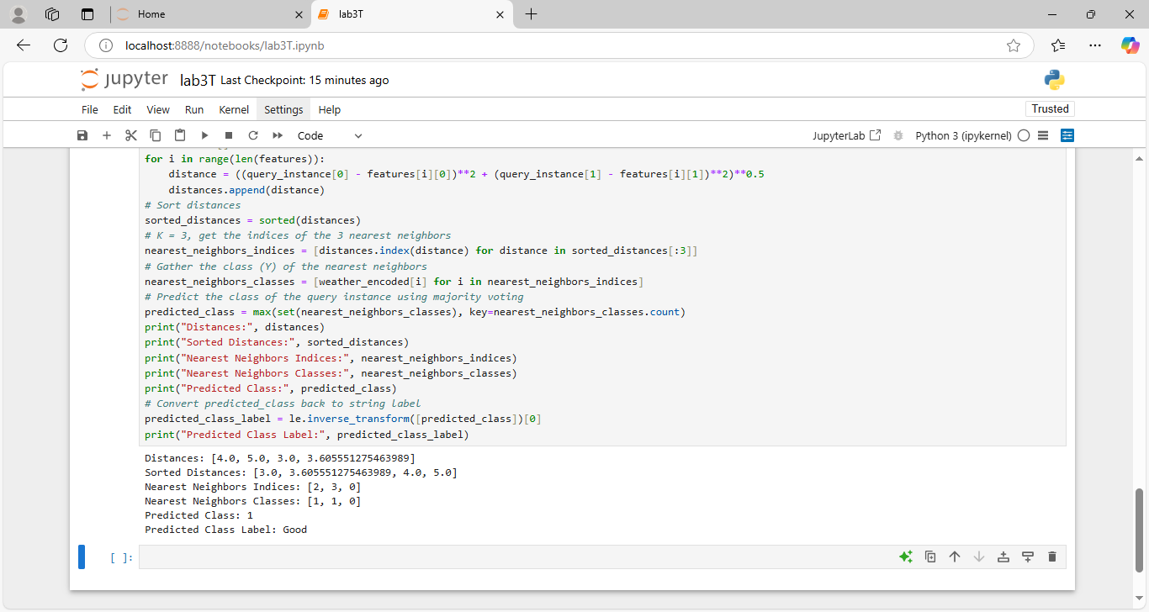

**OUTPUT:**



**Home Assignment:**

**Remote Work & Mental Health**

Analyzing Mental Well-being in a Remote Work Era

**OBJECTIVE:**

As remote work becomes the new norm, it's essential to understand its impact on employees' mental well-being. This dataset dives into how working remotely affects stress levels, work-life balance, and mental health conditions across various industries and regions.With 5,000 records collected from employees worldwide, this dataset provides valuable insights into key areas like work location (remote, hybrid, onsite), stress levels, access to mental health resources, and job satisfaction. It’s designed to help researchers, HR professionals, and businesses assess the growing influence of remote work on productivity and well-being.

Columns:

Employee_ID: Unique identifier for each employee.  
Age: Age of the employee.  
Gender: Gender of the employee.  
Job_Role: Current role of the employee.  
Industry: Industry they work in.  
Work_Location: Whether they work remotely, hybrid, or onsite.  
Stress_Level: Their self-reported level of stress.  
Mental_Health_Condition: Any mental health condition reported (Anxiety, Depression, etc.).  
Social_Isolation_Rating: A self-reported rating (1-5) on how isolated they feel.  
Satisfaction_with_Remote_Work: How satisfied they are with remote work arrangements (Satisfied, Neutral, Unsatisfied).

**SOURCE CODE:**

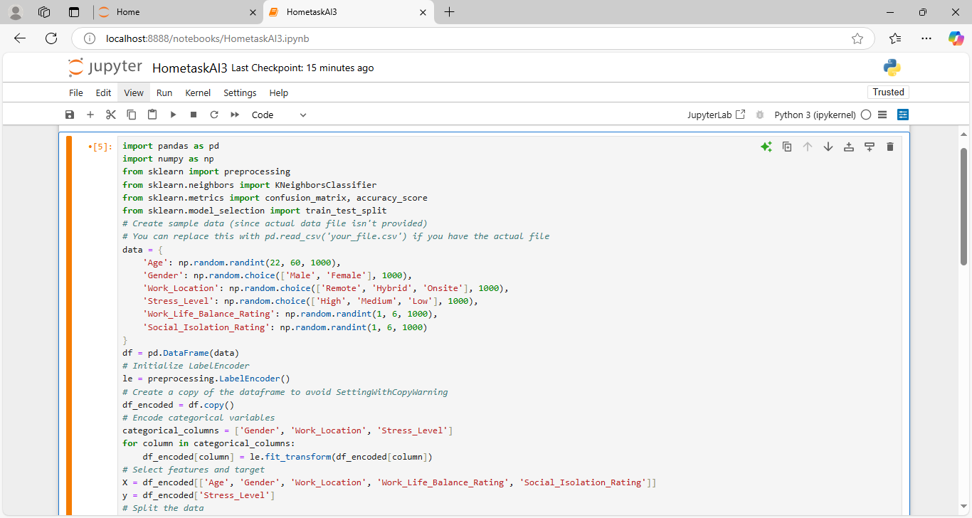

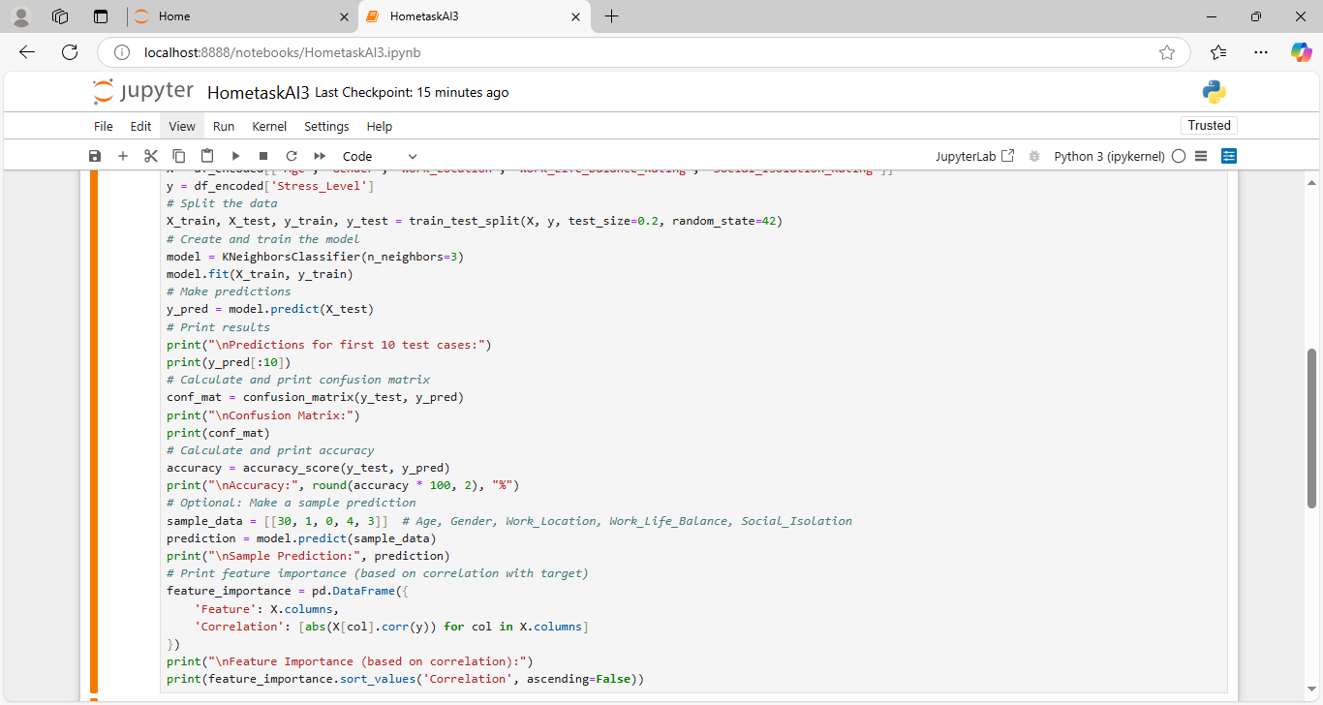

**OUTPUT:**

